**CASE STUDY -CORPORATE SOCIAL RESPONSIBILITY (CSR) – ACTIVITIES UNDERTAKEN BY AN INDIAN PSU (THDC INDIA LTD) COMPLEXITY AND CHALLENGES IN IMPLEMENTATION**

**Introduction (About THDC India Ltd):**

THDC India Limited is a Joint Venture of Govt. of India and Govt. of Uttar Pradesh. The Equity is shared in the ratio of 75:25 between Govt. of India and Govt. of Uttar Pradesh. The Company was incorporated in July’ 88 to develop, operate & maintain the 2400 MW Tehri Hydro Power Complex and other hydro projects. THDCIL is a Mini Ratna Category-I and Schedule ‘A’ CPSE.

The Corporation has grown into a multi-Project Organization with diversification into renewable sources of energy (wind & solar) spread over various States as well as neighbouring country, Bhutan.

**Case study of CSR:**

THDCIL’s CSR journey started in January, 2008 with sporadic charity activities such as distribution of sweaters in the neighbourhood of its Corporate Office, Rishikesh. THDCIL Board of Directors has approved its CSR-CD Scheme in the year 2008 itself much before the issue of Deptt. of Public Enterprises Guidelines for CSR.

The Honourable M.P., Tehri requested for construction of Community Centres, Delivery Rooms in the hospitals of the State Government in various blocks of Tehri District and these were consented by our management. A delegation of local leaders requested Honourable Minister of Power, GOI that THDCIL may construct Hydro Power Institute at B. Puram, Tehri and a hostel for SC & ST students in NTT. The same was agreed to by the THDC Management. THDC Institute of Hydropower Engineering & Technology’ is operational with all necessary infrastructure facilities. An exclusive hostel facility has been built for SC & ST students at New Tehri.

The journey gradually transformed from charity to sustainable CSR projects in a more organized and structured way with THDCIL’s Board of Directors approved CSR- Policy came into existence in the year 2010. THDCIL, now have combined CSR & Sustainability Policy in place w.e.f. 1st April, 2014.

**Allocation of CSR Fund**

Initially, under CSR-CD scheme, the fund allocation was upto 1% of the profit every year. Later with CSR Policy came into force, THDCIL started allocating 2% of its Net Profit before Tax subject to minimum of Rs. 3.00 Crore to Non-Lapsable CSR Fund for implementation of THDC CSR & Sustainability projects. Out of above, approx. 85% was utilized in neighbourhood of operational business location, i.e. Tehri Dam and balance CSR fund was utilized in the broad geographic areas, where THDC business extends such as Vishnugad Pipalkoti, Malari Jelam and Jelam Tamak HEPs, Rishikesh, Dehradun, Haridwar and various districts of UP.

At present, THDCIL ensures at least 2% of the average net profit of the Company made during the three immediate preceding financial years in compliance with Indian Company’s Act-2013.

**Beginning of the CSR Journey**

THDCIL started efforts to improve livelihood condition around Tehri Reservoir area mainly in ‘cut-off areas’ of Gajna Patti of Pratapnagar Block of Tehri District. THDCIL has contacted various experts in the social field for taking expert suggestions for implementing and monitoring of CSR works. For finding the ground reality of the cut off area, a meeting was convened under the chairmanship of Block Pramukh, Pratapnager on May 27, 2010. Representatives of Hon’ble MP, Tehri, MLA Pratapnager, D.M. Tehri, BDO Pratapnager, and about 100 Nos. Gram Pradhans, social experts, people from nearby villages and officers of SEWA-THDC were present in the said meeting. As the meeting proceeded with serious discussion, Smt. Jabra Rana, President, Tehri Bandh Sangarsh Samiti , Gajna Patti, Pratapnager stormed in and disrupted the meeting with approx 200 local people of Gajna Patti and Pratapnager Block. The protesters made 'gheraav' of officers, social experts and threatened that they will not allow any CSR work to be undertaken in cut-off area.

A local representative sat on 'Dharana' with supporters on 15.02.2011 in front of THDCIL's gate at Rishikesh which continued for 5 months. She raised unrealistic demands that `5.0 Lac be paid for each family of Gajna Patti for compensating their inconvenience due to disruption in road communication.

THDCIL assessed the basic requirements of people of Cut-off areas through one to one contact and data obtained from social experts. THDCIL has taken the view that direct cash compensation as demanded by Jabra Rana's Samiti is not desirable. Instead, welfare activities for the cut-off areas with emphasis on income generation schemes have to be initiated for implementation. Historically the public had negative perception about THDCIL. In this backdrop, CSR was started with entry level activities such as distribution of items of community utility such as utensils, chairs and tents etc. to the village panchayats. The communities rent out these items to local families for use during family functions and earn some income. The proceeds can be used for common benefit of communities. This would minimize the commuting effort and reduce cost to villagers for arrangement of marriage and other community functions. The village committee issues the utensils, chairs and tents to the needy villagers on payment of `1000/ for each function and the same is deposited in the village fund. The accumulated fund so earned could be utilized for the developmental activities of the villages.

In second phase, THDCIL started efforts to improve livelihood condition in ‘cut-off’ area villages, such as Gajna, Rainka and Dharmandal Patties of Pratapnagar and Jakhanidhar Blocks of Tehri District. Baseline/need assessment surveys are conducted for implementing the projects/activities as per requirement of the targeted areas. Various expert opinions/suggestions have been taken for implementation and monitoring of CSR works.

As message regarding THDCIL’s CSR initiatives spread among local community, huge demand from various corners of District Tehri Garhwal started coming apart from demands from outside Tehri under following heads:-

* Construction of Community Centres.
* Proposals from various N.G.Os.
* Construction of water supply schemes.
* Funds to be spent primarily for benefit of the people of cut off areas.

**Innovative Steps for Effective CSR**

Initially the CSR activities were being undertaken by THDCIL directly, but later it was felt by experience that desired progress is hardly possible in normal Govt. Organizational set up, in time bound manner. Beside this almost all the agencies/NGO’s, except few, engaged for CSR & SD projects are not acquainted with the tendering/ competitive bidding process and hesitate in participating bidding process. The process of exploring way outs to overcome above constraints gave birth to the innovative idea of formation of NGOs to implement CSR works in time bound manner.

**THDCIL’s NGO “SEWA-THDC”**

Considering all the facts and importance of long term effects, it was felt necessary to evolve an innovative mechanism though which the CSR & SD projects could be implemented and desired progress be achieved in a time bound /cost effective manner.

THDCIL Board of Directors felt that CSR & SD activities of the Company can’t be completed in time bound manner as per normal prevailing practices of the Company and directed to form an “NGO” for carrying out CSR & SD activities. The NGO came into existence with the name, “SEWA-THDC” after registration under Society Registration Act, 1860, in March, 2009. SEWA-THDC has started working since 2009-10. Aims and objectives of the society are charitable and non-profitable under Society’s Registration Act 1860. The Managing Committee has 07 members designated Senior Officers of THDCIL & nominated by THDCIL’s Board of Directors. CMD THDCIL is the ex- officio Patron of the society.

Thrust of THDCIL’s CSR & SD activities are on capacity building, empowerment of communities, inclusive of socio-economic growth, environment protection, promotion of green and energy efficient technologies, development of backward regions and upliftment of the marginalized and under privileged sections of the society.

The basic domains of CSR & SD programmes being executed by THDCIL are as under:

1. Educational Development.
2. Economic & Community Development.
3. Health & Veterinary Care.
4. Environment & Natural Resource Management.
5. Infrastructure Development
6. Women Empowerment and child care
7. Emergency need.
8. Other Social welfare activities.
9. Administrative expenditure.

**THDCIL’s NGO “THDC Education Society (TES)”**

TES is formed to impart education to the children of backward district of Tehri and Rishikesh. At present the society is running 03 schools under the auspices of TES-one at Bhagirathipuram, Tehri, Rishikesh & Koteshwar offering education from 1st to 12th standards. In all the schools children of nearby areas belonging to economically weaker sections including Backward and SC/ST are being provided education.

**Highly Qualified and Experienced Staff for CSR & SD**

Keeping in view the importance, management of THDCIL took innovative initiative and a team of 16 Officers were sent to Xavier Institute of Management, Bhuwaneshwar, Orisa for PG diploma in Advance Management in RR & CSR. The course was residential and for one year. All the 16 Officers have successfully completed the course and now deputed for implementation CSR & SD Programs.

**Major Education Initiative- THDC Institute of Hydropower Engineering & Technology:**

THDCIL has established “THDC Institute of Hydropower Engineering & Technology” at Tehri in the state of Uttarakhand spread over 20 acres of land with state-of –the- art infrastructural facilities and is fully functional.

**Innovative Idea of Holistic Development**

Thecommunity development programmes are identified and formulated based on the specific needs and requirement of the particular location emerged in base line studies, community consultation and Experts advice. Accordingly, following three long term sustainable CSR programmes were introduced:

1. Empowerment and Enhancement of Livelihood of 30 Rim Area Villages of Tehri Dam Reservoir in Pratapnagar Block by Integrated Development Approach through HNB Gharwal University, Srinagar.
2. Ecological Restoration and Socio-economic Empowerment of Rural Communities for Sustainable Livelihood and Resource Management in 10 villages of Upari Ramoli, Pratapnagar Block of Tehri Garhwal through Kirorimal College, Delhi University.
3. Livelihood security programme in 20 villages through farming system approach by Project Directorate for Farming System Research (PDFSR), Modipuram.

The details of above programmes are also available on the website of THDCIL.

Third party assessments have been done for CSR works through Tata Institute of Social Science Bombay (TISS), SR Asia and experts from universities. They have appreciated THDCIL’s CSR initiative.

These projects are also published in various national news papers & telecasted by National news channel.

**Innovations during Implementation**

1. **Concept of SHGs, Revolving fund**

For long term Projects of sustainable livelihood approx. 150 Self help Groups (SHGs) of likeminded people have been formed with initial help of lump sum amount of Revolving fund on returnable basis to start with the activities eg; Poultry, Goatery, growing of vegetables, masala cluster etc. After strengthening of these SHGs, efforts are made to revolve the returned fund to new SHGs or utilize for a new activity.

**b- Concept of Gram Kosh**

Villagers are being encouraged to deposit some nominal amount in Gram Kosh run and managed by group of people from their earnings from different CSR activities for their own welfare activities.

**Details of various activities undertaken through Holistic Development Projects**

Holistic development activities are mainly being conducted through two Nodal Centres, established at village Deengoan in Pratapnagar block and at village Bhuniyara in Jakhnidhar block of Tehri District. Agriculture demonstration Farms were developed for introduction of innovative method of farming and changed cropping pattern according to local situation, to educate the people with modern techniques and to motivate other farmers to adopt such techniques. European herbs Oregano, and some other new crops were introduced in the villages.

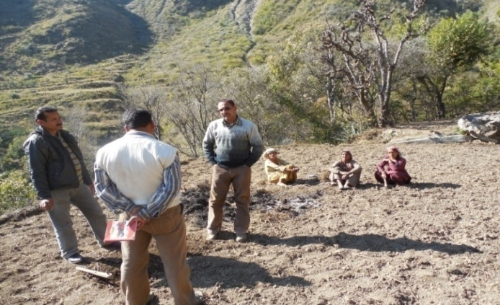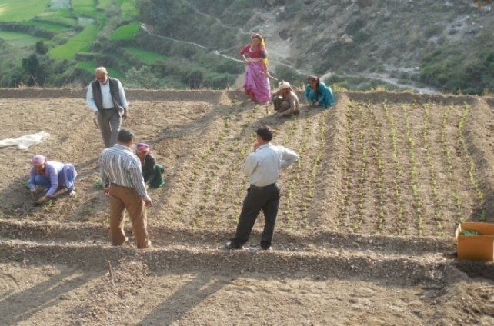

***Practical Training through Experts***

Libraries are also established at these centres so that local youth are benefited. Various types of vocational trainings are also conducted at these centres. It is an innovative experiment which provides vocational training of computer, Stitching etc. Deengoan centre is also providing healthcare facilities to the community.

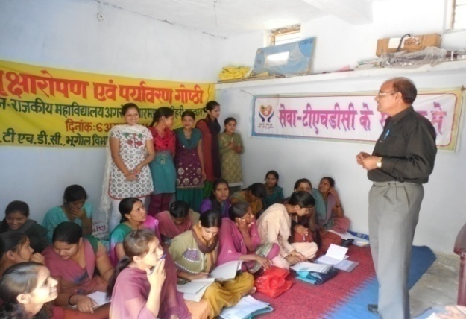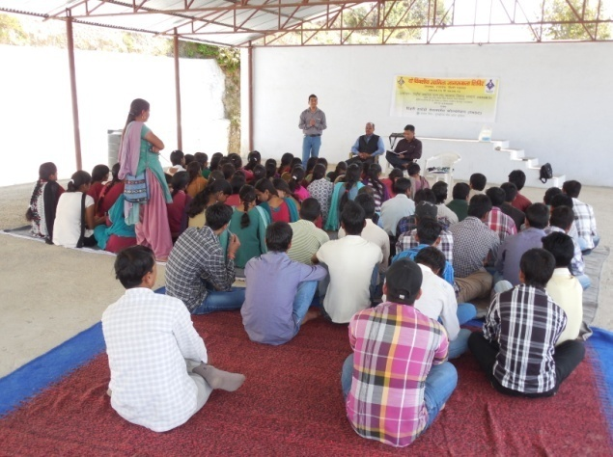

***Interaction session at Nodal Center Bhuniyana village***

1. **Promotion and Strengthen of Farmer Self Help Groups (SHGs)**

The primary focus of this activity was to enhance the social and financial capital of the poor, women, dalits, and BPL families estimated to be 70% of the project area population. It is observed that almost 1500 Women of 60 villages are directly involved and benefitted by the SHGs in Pratapnagar, Jakhnidhar and Koteshwar area. Now they all are accessible to new opportunities such as money saving, microfinance, loans, getting subsidies, linkages with banks, vegetable cultivation and income generation. Through this small saving they meet their emergency need and learn collective decision. As reported these SHGs are able to save more than Rs. 50.00 lacs and this all fund is now deposited in local cooperatives banks or national banks. Almost all SHG are having separate passbooks. Nearly 100% of SHG members are trained on social mobilization, credit management and self monitoring. Now we are in a process to form federations or women cooperatives of these SHGs which will ultimately manage and control the fund and link these SHGs with market and Banks.

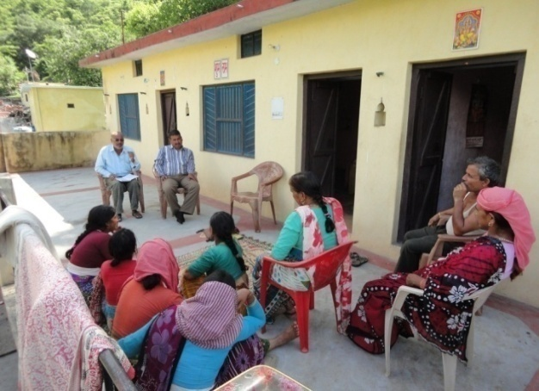 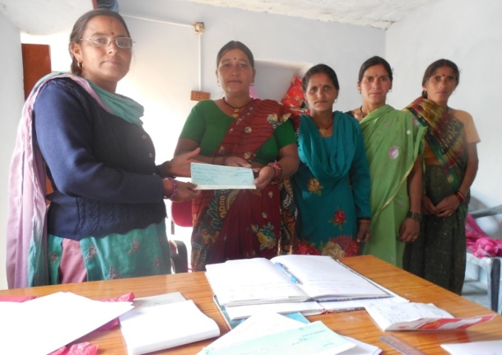

Cheque distribution to SHGs

Meeting of Self Help Groups

1. **Bee keeping**

Beekeeping contributes to support sustainable livelihood in poor and remote communities and honey bees provide an essential ecosystem services to the villages. Hence, the activity was taken up with interested farmers. Training was given to the selected farmers in bee keeping. Trained farmers take care of boxes and ensure their maintenance apart from supervising honey extraction. Priority has been given to those farmers who are living below poverty line.

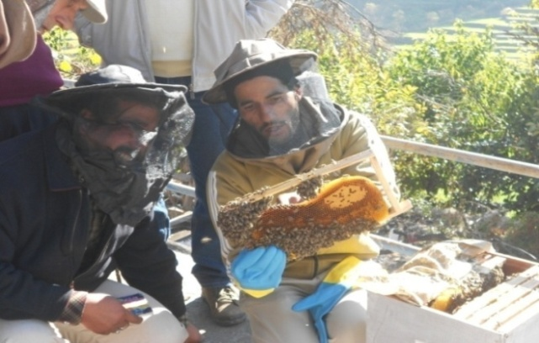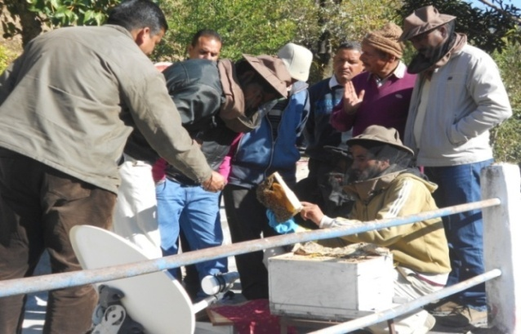

***Training on Bee Keeping***

1. **Promotion of off seasonal vegetable:**

This activity was successfully implemented by involving local families forgrowing vegetable.High breed seeds were distributed to the farmers. The families earned Rs. 5000/- to Rs. 27000/- from selling these vegetable in local market. Since the local market for off seasonal vegetable is expanding with attractive prices at local level, there is great scope for vegetable production.

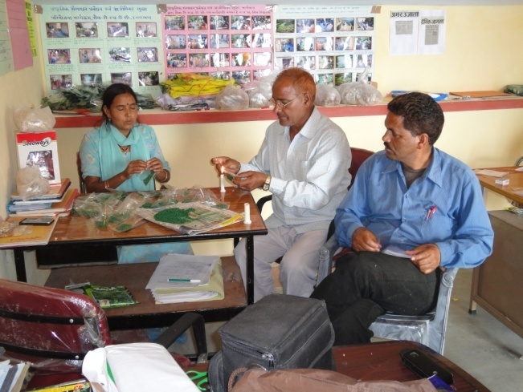 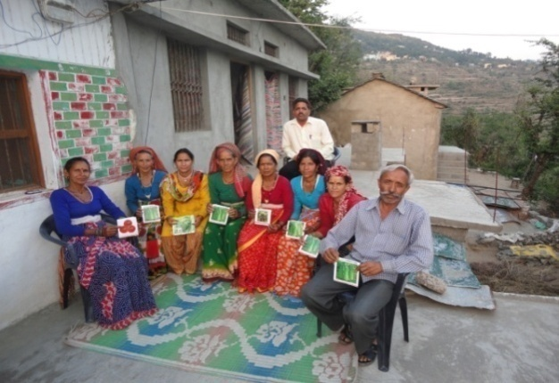

***Packaging and distribution of high yield seeds to the villagers***

1. **Goat Rearing & Poultry Farming**

Realizing the importance of Goatery & Poultry in the agrarian economy, both the activities were introduced for poor farmers.

Goat is a multi functional animal and plays a significant role in the economy and nutrition of landless, small and marginal farmers in the country. Goat rearing is an enterprise which has been practiced by a large section of population in rural areas. Goats can efficiently survive on available shrubs and trees in adverse harsh environment, in low fertility lands where no other crop can be grown. The activity contributed to their livelihood.

A project of poultry farming was also implemented in Pratapnagar and Thauldhar block of Tehri district. Around 300 poultry units were established within three year. These units are running successfully and beneficiaries are gaining profit.

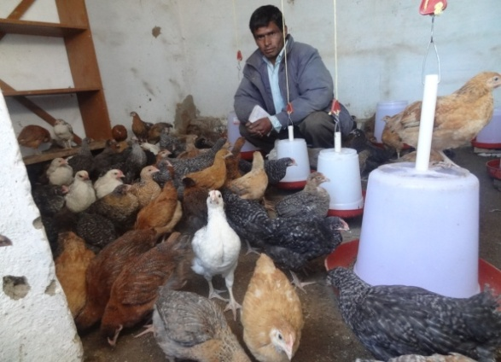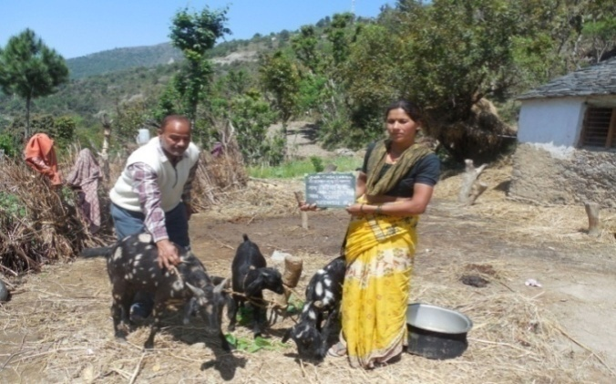

***Beneficiaries of Pratapnagar, Jakhnidhar & Thauldhar Blocks, Tehri Garhwal***

1. **Expanding and strengthening MMDs for income generation through traditional crops, vegetables and spice marketing**

Mahila Mangal Dals (MMDs) can be defined as "self governed, peer controlled information group of people with similar socio-economic background and having a desire to collectively perform for common purpose." Major aims for the formation of MMDs are to mobilize individual skills for group's interest, to create awareness about right, Entrepreneurship development, to identify problems, analyzing and finding solutions in the groups, to act as a media for socio-economic development of village, to develop linkage with institution of NGOs, to gain mutual understanding, develop trust and self-confidence and to build up teamwork. It is a visible organized setup of poor rural women and is time to time encouraged in entrepreneurial activities. MMDs generally organize regular meetings and discuss women related issues.

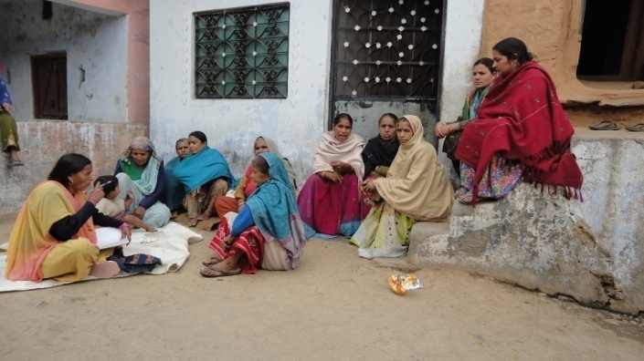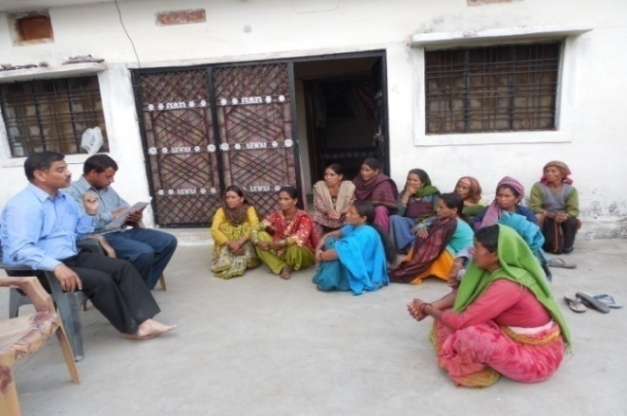

***Monthly meeting with MMDs members of Project effected villages***

1. **Establishing Multipurpose Nurseries and Plantation:**

For improving the biodiversity of the villages and to use the area of land where the forest has been harvested or damaged, plantation activity was taken up. To fulfil the plants requirement in the nearby areas these nurseries were developed with the help of local villagers. For plantation a training workshop was also organized through experts. It was felt that there is a need to increase the level of awareness among the villagers in the development and rehabilitation of waste lands in a sustainable manner through participation in tree plantation activity. Multipurpose nurseries included plants like; Mulberry, Reetha, Lemon, Baanj, Kachnar, Aawla, Bahera, Tun, Padam, Chullu (wild apricot) etc. Almost two lac plants have been planted so far.

The Fruit plants are an extremely important natural resource for sustaining livelihoods in the villages. These resources need to be utilized on a sustainable basis in the long run. Keeping this in view, very high quality fruit plants were distributed to the villagers. Species of the fruits distributed to the farmers were; Mango, Guava, Annar, Kinnu, Bel, Kathal, Akrot, Badam, Jammun, Litchi. There is now increasing demand of fruits plants in the villages.

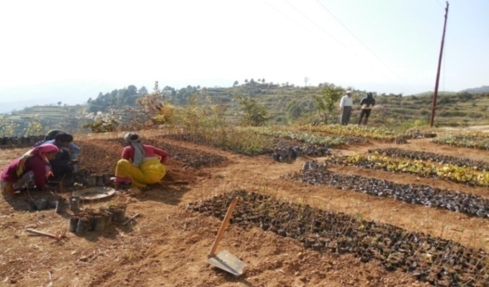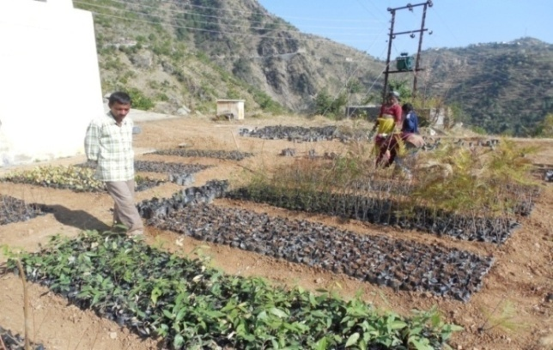

***village women working in Agrora nursery***

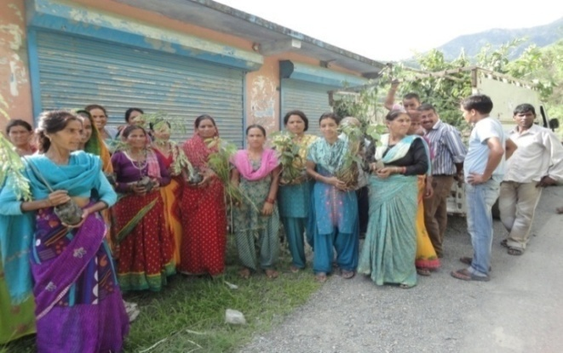 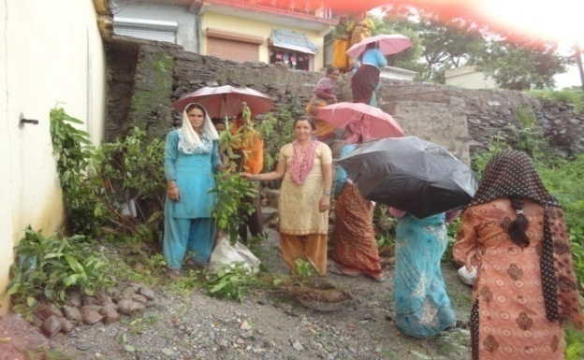

**Distribution of fruit plants in the effected villages**

1. **Fodder Demo Plot – Napier Grass**

Fodder shortage is one of the main issues affecting the development of villages of rim area. It leads to both poor quality mulch animals, and the degradation of forests. Given the reality of fodder scarcity in affected villages the activity ‘development of fodder plots’ is initiated. Overall, an additional income of Rs. 2,500 was generated from fodder grass. Over 500 households covering the population of 3000 mostly marginalized villagers are directly or indirectly involved with this activity. With the increased availability of nutritious fodder, the adoption of better preservation and feeding practices, and breed improvement, the average milk yield of cattle is expected to increase from 2.4 litres per animal per day to 04 litres per animal per day. It is a successful activity reduced workload on women and provides high quality fodder to villagers. It also ensures women involvement in every step.

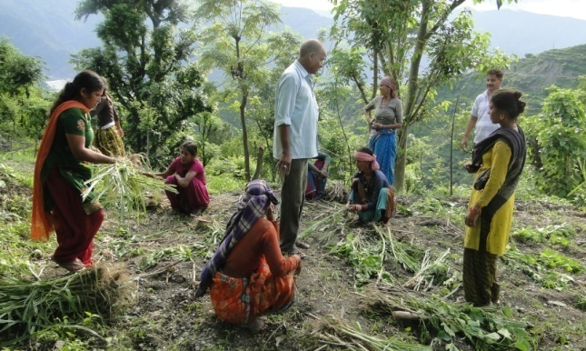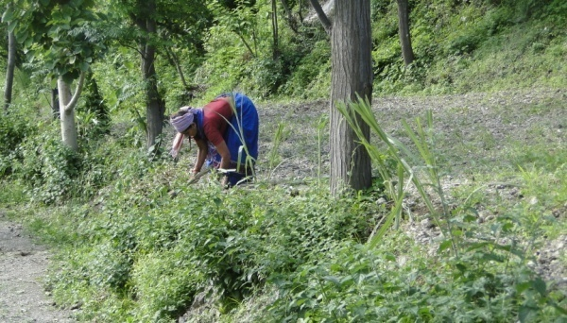

***Village Women are harvesting Nappier Grass Plantation***

1. **Big Poly Houses**

The major benefit of the poly house is that it increases in production capacity of the crop by reducing time period.  One can get production 4 to 5 times in a year. It also gives uniformity in plant growth with good vigor. It also provide quick take off with little or no transplanting shock. Due to all this Poly houses are being established as per the requirement of villagers.

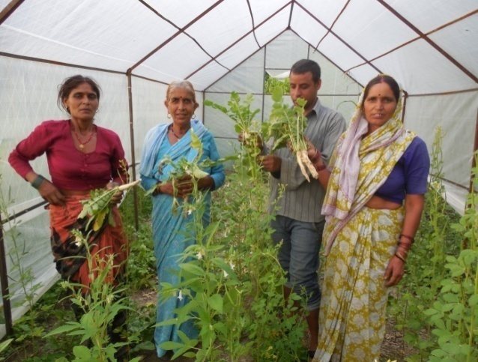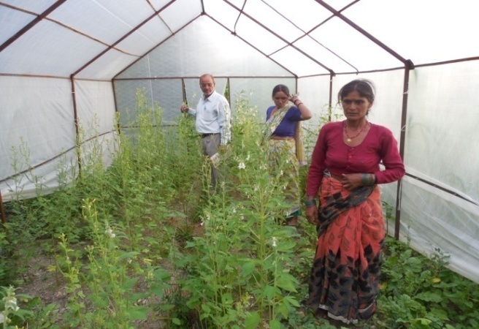

***Women farmer Group members growing radish vegetable in Poly house***

1. **Awareness Generation through Kissan Gosthi, Environmental Awareness, Yoga, Health and Ayuredic Medicine Awareness Camps**

Time to time awareness generation camps for the villagers was organized. Experts from different fields provided counselling to women. Counselling sessions were also organized to address the issues and problems of deprived rural population like children, women and vulnerable groups. Kissan Goshties were conducted to give the farmers latest updates and help them having increased produce.

Advocated for improved Chulha. Women have also shown great interest in improved chulhas. Meetings with farmers were conducted regarding needs to change agriculture and land use patterns to improve income and livelihood. Awareness programmes were also conducted for Legal issues.

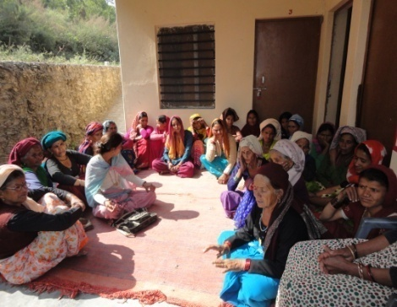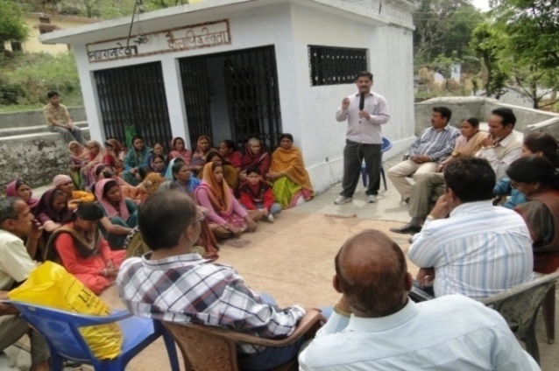

***Awareness Camps in effected villages***

1. **Medical Camps/ Facilities**

Medical facilities were provided especially amongst woman and children by establishing Homeopathic Dispensaries at Galiyakhet, Dhontri, Rishikesh & Koteshwar. Free Homeopathic Medicines is distributed to the needy patients from remote areas of Hills. People of almost 50 villages are benefited during last 2-3 years.

Every year 10-15 multi speciality camps are organised by THDCIL in different areas of district Tehri, wherein approx. 250-300 persons are examined for treatment of various diseases including surgical operations.

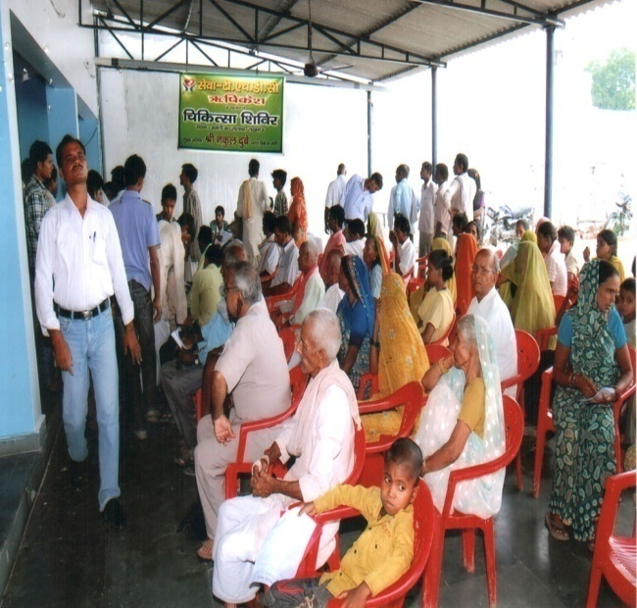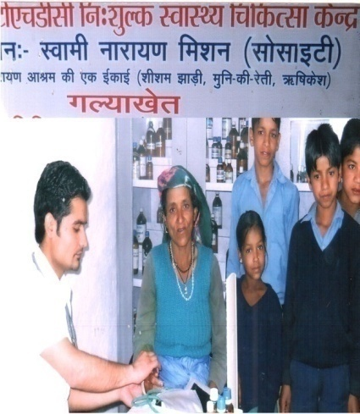

***View of Dispensary & medical Camp***

1. **Intervention in Animal Husbandry**

In animal husbandry various interventions have been carried out for economic up-liftment of the farmers through increase in milk production. These are de-worming, medicine for heat inductions, fodder nutrients and mineral mixtures for balance nutrition of mulching animals.

1. **Latest information and techniques in crops/vegetable & improving low crop production**

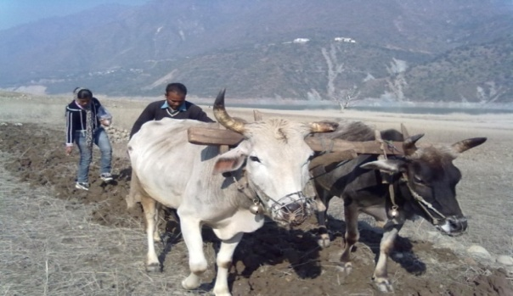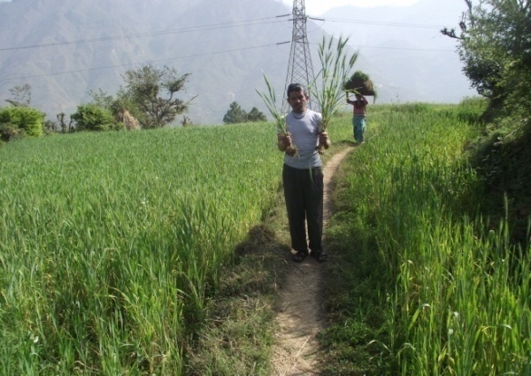

***Line sowing method of cultivation Improved seeds***

Detail information regarding traditional method of agriculture and resources used for different crop production was collected from villagers of concern clusters through expert team of agriculture scientists of PDFSR, Modipuram and problems of villagers were analysed on the basis of soil testing of agricultural land. Necessary information was provided to villagers to improve their soil quality through use of vermin compost, essential fertilizer and nutrients. The latest information and technology in agriculture equipments was provided to villagers which are handy and useful in hilly region which led in reduction of cost of seed used in crop production through line sowing method of cultivation.

**Soil and water conservation activities**

Construction of Check Dams is an effective technique to controlling upstream slope stabilization and it also control sediments. Hence, Check dams were constructed at selected locations. Chal-khal, trenches and water recharge pits were also excavated to enhance the ground water level. These structures are able to recharge natural springs of Kangsali and Baseli Gad and ultimately villagers can manage their ground water resources through rain water harvesting.

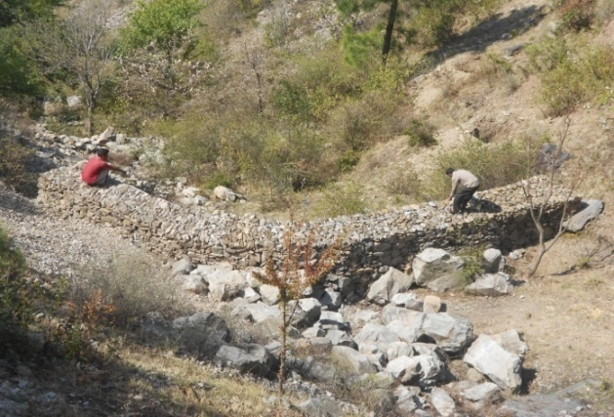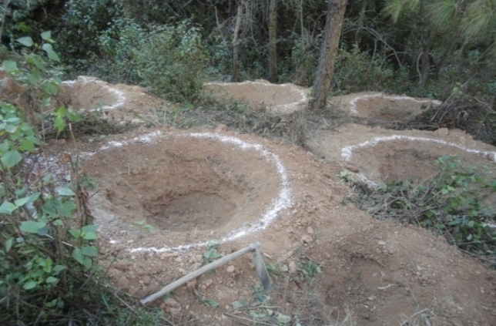

**C*heck dam for water & soil conservation Water recharge pits***

1. **Midterm review Workshop and Feedback from the experts**

Sharing and learning workshops are being conducted, wherein people from other NGOs working in the hills region, academicians, Government officials, research scholars, media persons, PRI representatives and the beneficiaries are invited. The workshops are a platform where different views were shared between stakeholders and Govt. officials. It provides unique opportunity to share experiences and issues with different stake holders and organizations and exchanged insights, ideas, challenges and possible solutions.

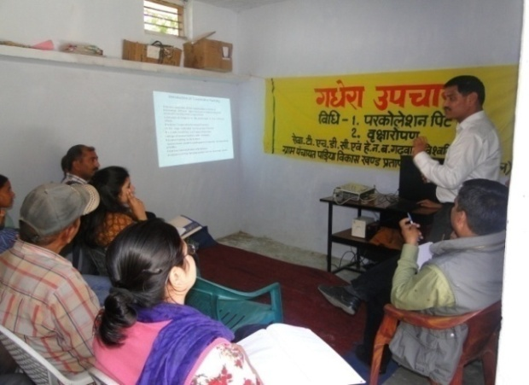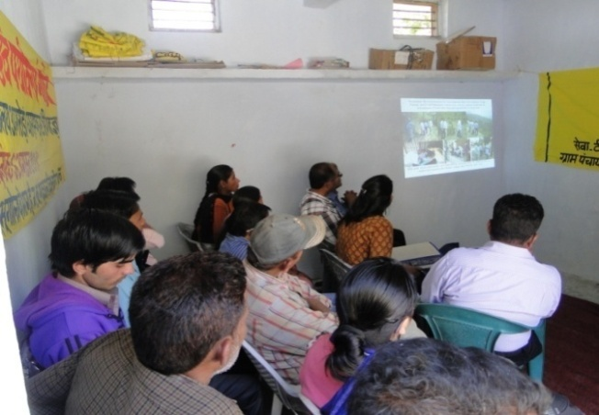

***Tata Institute of Social sciences experts interacting with project team***

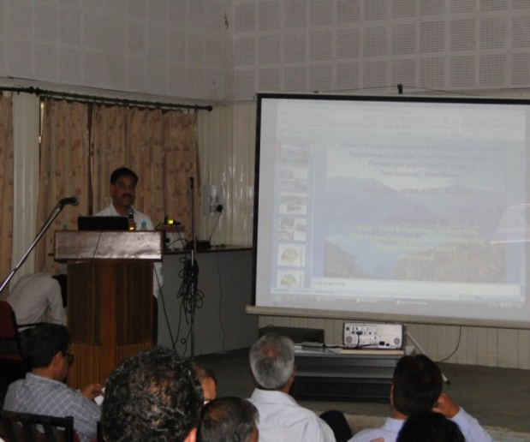 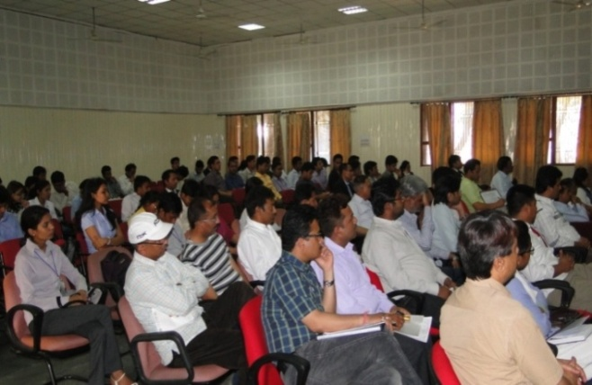

***Sharing workshop of the Projects undertaken***

**CSR & Sustainable Development activities in Uttar Pradesh (UP)**

UP is one of the most socially diversified state of India and 25% equity holder of THDCIL. Few CSR activities were started in UP in Majhwara (Sultanpur), Jaise (Raebareli), Munsigunj (Raebareli), Itonjaa (Lucknow), Old Lucknow, Nagram (Lucknow), Tanda (Ambedker Nager), Miranpur (Ambedkar Nager) and Hajratpur (Barahbanki) for Minorities and Other Weaker Section Women & Girls with a view to upgrade skills and enable them to start income generation on their own or get gainful employment.

Cutting, Tailoring & Knitting, Computer Training, Chicken Embroidery and English Speaking programmes for six months duration were implemented on the basis of recommendation given in PRA reports and by social experts.

**CONCLUSION**

As the name of the Projects indicates the innovative objectives undertaken by SEWA-THDC i.e. to enhance the livelihoods and also empower the villagers to be able to sustain the benefits are received. The projects helped the villagers attain an increase livelihood and through innovative approach and awareness sessions they became more aware of the latest knowledge in the sector.

The success of THDCIL’s CSR programme lies in the fact that there seems an apparent change in people’s perception in cut-off and other surrounding areas. Even, Smt. Jabra Rana now supports THDCIL’s CSR and that too without accepting her demand of compensation of Rs. 5.0 lacs to each family of Gajna Patti.

THDCIL’s CSR Programme has brought smile on the faces of deprived classes in cut off areas.

Recently, THDCIL got evaluated its major CSR projects implemented in last three years from “Tata Institute of Social Sciences (TISS)”, Mumbai. THDCIL’s intension & efforts towards improving lives of the people also reflects in the concluding statement of TISS as follows-

“The interventions undertaken by THDCIL have the objectives, vision and mission in place and the projects are implemented effectively. Experts are involved in each project which has given a new meaning to projects undertaken. It is hoped that the initiative undertaken by THDCIL continues to make a difference in the lives of people”.

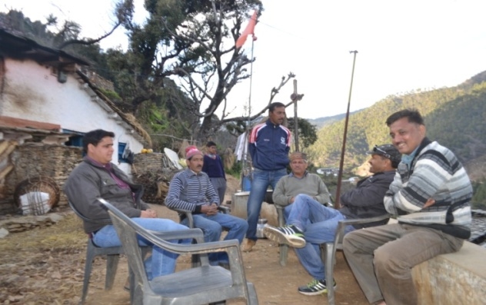

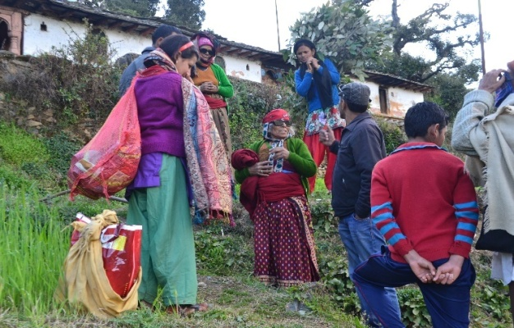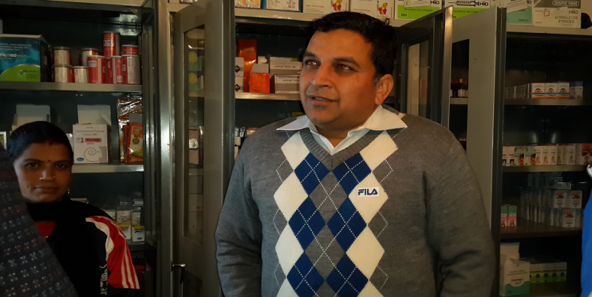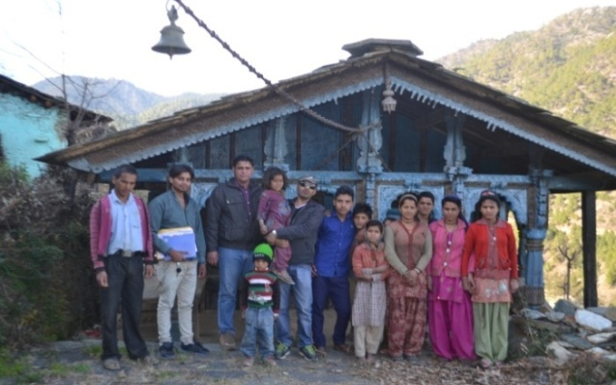

Social Responsibility Asia (SR Asia) has evaluated the long term CSR projects of THDC during the year 2015. The project modelling is found to be unique and delivery has been well appreciated by the people / beneficiaries in the region. The CSR projects are in the shape of institutionalisation which is a good sign for positive and lasting impact on the intended objectives. At present, the focus is on Health, Education, Sanitation, Water harvesting, Livelihood and Income generation activities which are very important given the socio economics of the area. The beneficiaries further wants the project scaled up so that more people can be benefited, more awareness program are requested to be held for sensitizing the schemes so that sustainable change is achieved.

**References:**

1. Indian company act-2013 on CSR
2. Indian Act on Land acquisition 2013
3. National Voluntary guidelines (NVG) Ministry of Corporate Affairs Govt of India
4. ISO 26000:2010
5. OECD Guidelines on CSR for Multinational Companies
6. THDCIL CSR Annual reports, Sustainability reports & THDCIL’s website

**Acknowledgement:**

The authors acknowledge the tremendous support and encouragement received from SEWA-THDC management team while writing this paper. Special thanks to the then SEWA-THDC President Mr. H L Bharaj, Mr. S.R. Mishra, GM (S&E)/ President (SEWA-THDC), THDCIL officer’s Mr. Shailendra Singh (AGM), Mr. Vijay Sehgal (DGM), Sh. Amardeep Singh (DGM), Sh. Anil Bhat, (Sr. Mgr) & Sh. Vipin Thapliyal (Mgr). We are also indebted to the THDCIL site project officers for sharing the information including the other stakeholders.

**About the Authors**

1. Mr. Birendra Raturi, International Director SR Asia, He has over 20 years of experience in the various fields and sectors in India and overseas. He is a training faculty with CBI the Netherlands government, Inwent Germany, Power HR forum, CII. FICCI, ELCINA etc. He led a **first CSR project study** in India in 2011 funded by CBI along with the FICCI. He has conducted imparted training on CSR and conducted impact assessment of CSR project of various PSU like THDC, NTPC, NHPC, RECL, etc. He is **certified professional on ISO 26000** and has developed a self e-learning program on ISO **26000:2010 on Social Responsibility** for Asian Productivity Organization (APO) Japan where in more than 5000 participants over 80 countries attended the program.
2. Mr. Rakesh Khare, Former Executive Director THDC India Ltd, He has over 38 years of diverse experience in various PSUs and in the field of CSR and Sustainability comprising of **Training and Development** and large CSR project implementation. He has already conducted **CSR Training in many PSU like NTPC, NHPC, HAL** etc. He has experience of handling open meeting with more than 100 villages. He has been selected among the **top 50 CSR** influential leader in the country.
3. Dr K K Sharma, an Associate professor with Geography Department in KMC, Delhi University. He is the project director for implementing one of the long term CSR project in the district of Tehri. The project is supported by SEWA-THDC. Dr K K Sharma works with various PSU on the different kind of assignment related to CSR and Sustainable Development.
4. Dr M.S. Panwar, an Associate professor with Geography Department in HNB Garhwal University. He is the project director for implementing one of the long term CSR project in the district of Tehri. The project is supported by SEWA-THDC.